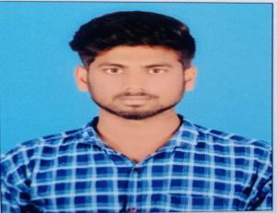

**LOGESH ARAVINDH**

My carrier objective is to develop more and more technologies and bring it to society and to make our society safe and secure through Technologies.

**CAREER OBJECTIVE**

Email :dlaravindhtechie@gmail.com

Phone：9360481969

Address:1/399,palakaruthampatty

Pannankombu,Manaparai

Trichy-621306

**CONTACT ME**

* Certified in HTML and CSS in guvi
* Certified in JavaScript in guvi
* Certified in python in guvi

**LANGUAGES KNOWN**

* TAMIL
* ENGLISH

**PERSONAL DETAILS**

* NAME : LOGESH ARAVINDH D
* FATHER NAME : DURAI SAMY P
* DOB : 09-DEC-2000
* MARTIAL STATUS : SINGLE
* NATIONALITY : INDIAN
* COMMUNITY : DNC
* LANGUAGE KNOWN : TAMIL, ENGLISH

**TECHNICAL QUALIFICATIONS**

HTML & CSS

JAVA SCRIPT

JAVA

MY SQL

PYTHON

**SKILLS**

I can handle the tough situation without any fear.

I can learn new languages and updates more faster.

**SPECIAL SKILLS**

CREARIVE

LEADERSHIP

TEAMWORK

CONFIDENT

**PROFESSIONAL**

* BE from kurinji College of Engineering and Technology in 2022 (CGPA 8.20/10)
* HSC from Thiakesar Alai Higher Secondary School in 2018 with 60%
* SSLC from Thiakesar Alai Higher Secondary School in 2016 with 89%

**EDUCATION**